**Berlin’s techno scene added to Unesco intangible cultural heritage list**

Designed to preserve and assist cultural traditions, the list recognised techno scene’s contribution to Berlin’s cultural identity

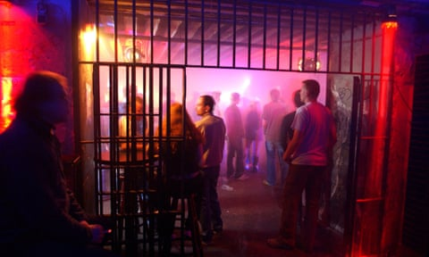

Berlin’s techno scene has been added to a [Unesco](https://www.theguardian.com/world/unesco) cultural heritage list, in recognition of its contribution to the cultural identity of the city.

Berlin’s Clubcommission, a network for Berlin’s techno clubs and musicians, [described](https://twitter.com/clubcommission/status/1767979957173580132) the move as “another milestone for Berlin techno producers, artists, club operators and event organisers”.

Created in 2003, the intangible cultural heritage list is designed to preserve and assist cultural traditions which can include music, art, beliefs, cuisine and dance.

For more than a decade there has been a campaign to have techno culture and music added to the list, spearheaded by Rave the Planet, a non-profit supporting electronic music culture.

“Congratulations to all the cultural creators who have shaped and contributed to Berlin’s techno culture,” the group said in a statement on social media. “This is a major milestone for the entire culture, and our joy is beyond words.”

Techno is a fundamental part of the city, according to Peter Kirn, a Berlin-based DJ and music producer. In 2021 he told the Observer: “In other cities, people wouldn’t accept music that’s really hard or weird and full of synthesisers and really brutal, distorted drum machines. You can’t play that at peak hour in a club, let alone over lunch. And here it’s totally acceptable to play that over lunch.

“Techno has become a refuge for people who are marginalised, and there’s a natural attraction to Berlin as a place which is more permissive when you come from places that are less permissive.”

The techno scene is one of six new entries on the intangible cultural heritage list in Germany; others include fruit wine and mountaineering. A parade in Bavaria known as the Kirchseeoner Perchtenlauf, where attenders dress as furry monsters, was also added to the list.

Germany now has 10 entries on Unesco’s intangible cultural heritage list.